# **JOB DEFINITION: -**

### **THE OPERATING PROCEDURES FOR THE CARTER MIXER COMPUTER FOR START UP, RESETTING AND COMPOUND CHANGES**.

## JOB SPECIFIC HEALTH AND SAFETY: -

**HEALTH & SAFETY INSTRUCTIONS & NOTICES THAT ARE DISPLAYED IN THIS AREA ARE TO BE ADHERED TO AT ALL TIMES**



Ear protection to be worn

Hand protection to be worn





Prepare yourself with all necessary **PPE**.

1. **EAR DEFENDERS** to be worn at all times if in mandatory area.
2. **BEWARE** of trapping hands and clothing in machine moving parts.
3. Care should be taken at all times when **MANUAL HANDLING. BACK BELTS** to be worn when manual handling. Always use the available mechanical handling equipment.
4. Always ensure **GOOD HYGIENE** practices and use **BARRIER CREAMS** when handling rubber compounds.
5. **GLOVES** are to be worn when handling chemicals.
6. Care should be taken when using knives. When not in use, cover blade or return to holder.
7. **COSHH / RISK ASSESSMENTS** and **SAFETY DATA SHEETS** are available from supervision or Health and Safety Manager.
8. **PROTECTIVE FOOTWARE** must be worn at all times**.**

All employees must take reasonable care for the Health and Safety of themselves and of others who may be affected by what they do or fail to do at work. This duty implies not only avoiding obvious reckless behaviour, but also taking steps to understand the hazards in the work place. To comply with Safety rules and procedures and to ensure that nothing they do or fail to do puts themselves or others at risk. (H.S.W.A. 1974, Sec: 7a).

E.g. Wear the Personal Protective Equipment

Do not tamper with the machinery

Observe manual handling instructions

Keep work areas clean and tidy.

This list is not exhaustive but further information can be obtained from your immediate supervisor, manager, director or the Company Health & Safety Policy arrangements.

**MIXER CONTROL SCREEN LAYOUT**

**COMPUTER START UP**

Action 1 Set up computer for mixing production.

Safety 1 **EAR DEFENDERS** to be worn at all times if in mandatory area.

Quality 1 When the mixer power is turned on, the computer console needs to be set up before automatic mixing can commence. Check that all the pumps and fans are working, log in and select the compound mixing cycle.

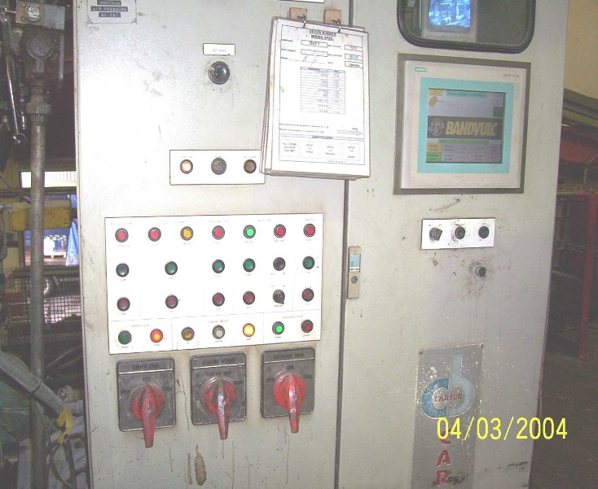

Red Levers for

Manual Control

Pump fans & Drive Start/Stop

Computer Touch Screen Display

Alarm Accept Button

Start Batch Cycle

Photo 1

When the computer has loaded “Screen 1” will be displayed.

Screen1 *111*

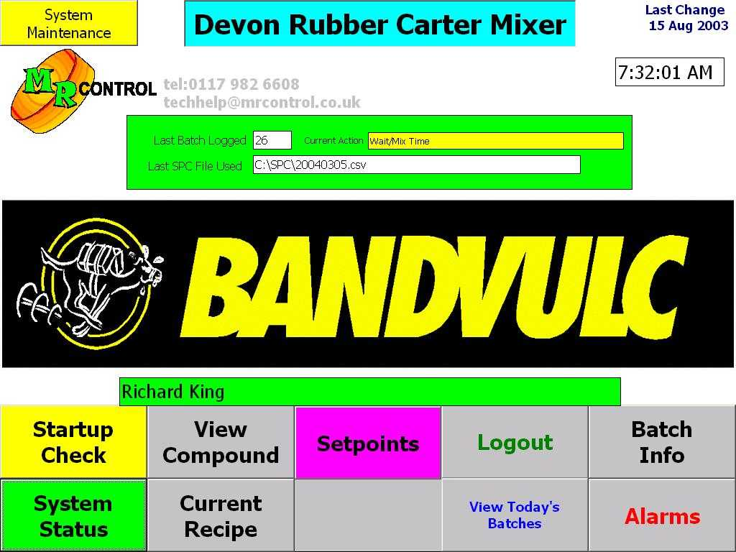

**LOGGING IN AND OUT**

Action 1 Log into the computer

Safety 1 **EAR DEFENDERS** to be worn at all times if in mandatory area.

Quality 1 To log in press the “Log In” button from the main menu.Type in your number and your PIN number. Logging in is important as it can inform the management at any time who is operating the mixer. You must however, “Log Out” when you leave the mixer. To do this press the “Log Out” button on the screen. The next operator is then responsible for logging themselves in as the new operator.

**HOLDING AND RESETTING CYCLE**

Action 1 To hold and reset the cycle.

Safety 1 **EAR DEFENDERS** to be worn at all times if in mandatory area.

Quality 1 The computer will hold either when the “Hold Cycle” is pressed or when any of the red levers are turned out of automatic. This allows blockages or alarms to be cleared. The screen will display a flashing red “Hold/Reset” message. To continue the cycle all 3 levers must be in automatic and the computer “Hold” button pressed again.

**RESET**

Action 1 To reset the mixing cycle press the flashing reset button on the screen when in hold.

Safety 1 **EAR DEFENDERS** to be worn at all times if in mandatory area.

Quality 1 The screen will change and give you the option to confirm the reset with Yes/No. Press the Yes to reset. The computer will then be able to start at the beginning of the cycle.

**COMPOUND CHANGE**

Action 1 To change the compound.

Safety 1 **EAR DEFENDERS** to be worn at all times if in mandatory area.

Quality 1 Press the “View Compound” button from the main menu screen 1. A list of compound mixing cycles will be displayed (Screen 2). Select the new compound number in the “Last Recipe Loaded” box. Once selected return to “System Status”. Press the green “start cycle” button on computer console under the key pad. When a compound change has been done, the buzzer button must be pressed twice to inform the rest of the factory and especially the mill operator that a change has been made.

Press to load new compound

Screen 2

